**TRIBUTE PAGE**

**A MINI PROJECT REPORT**

***Submitted by***

**Group/Team No: G1/B**

**ADARSH KUMAR GUPTA, 2210991177,**

**ADARSH KUMAR PATHAK, 2210991178,**

**ADARSH RANJAN, 2210991179,**

**ADAITI, 2210991180,**

***in partial fulfillment for the award of the degree***

***of***

**BACHELEOR OF ENGINEERING**

***in***

COMPUTER SCIENCE & ENGINEERING



**CHITKARA UNIVERSITY**

**CHANDIGARH-PATIALA NATIONAL HIGHWAY**

**RAJPURA (PATIALA) PUNJAB-140401 (INDIA)**

APRIL-JUNE,2023

**ABSTRACT**

A tribute page is a special way to honour and pay respects to someone who has made a significant impact on our lives. It is a space to celebrate their achievements, remember their legacy, and express our gratitude for the contributions they have made. Whether it's a beloved family member, a close friend, or a public figure who has touched our hearts, a tribute page serves as a lasting tribute to their memory. Through words, images, and memories, we can create a beautiful tribute that honours the life and legacy of those we love and cherish.

This tribute page explores the remarkable career and profound impact of the esteemed actor, Robert Downey Jr. Known for his captivating performances, versatile acting range, and charismatic personality, Downey has solidified his status as one of Hollywood's most celebrated and influential figures. This tribute chronicles his journey from a promising young talent to a true cinematic legend.

The tribute delves into Downey's early life, providing insights into his upbringing and the early signs of his extraordinary talent. It examines his breakthrough roles, such as the iconic portrayal of Tony Stark, a.k.a. Iron Man, in the Marvel Cinematic Universe, which catapulted him to global superstardom. The page showcases Downey's exceptional ability to breathe life into diverse characters, ranging from intense dramas to witty comedies, earning him critical acclaim and numerous accolades throughout his career.

Moreover, the tribute pays homage to Downey's resilience and personal growth, highlighting his triumph over adversity and battles with substance abuse. It emphasizes his inspiring journey of redemption and transformation, which resonates deeply with fans worldwide, making him a beacon of hope and inspiration.

Additionally, this tribute acknowledges Downey's contributions beyond acting, including his involvement in charitable initiatives, environmental activism, and his strong advocacy for mental health awareness. It underscores his commitment to making a positive difference in the world and his unwavering dedication to giving back to society.

Through a combination of compelling narratives, captivating images, and notable achievements, this tribute page celebrates Robert Downey Jr.'s indelible mark on the entertainment industry and his enduring legacy. It serves as a testament to his extraordinary talent, his ability to connect with audiences on a profound level, and his enduring influence on the world of cinema.

Top of Form

Bottom of Form

**TABLE OF CONTENTS**

|  |  |  |
| --- | --- | --- |
| **Sr.no** | **Section** | **Page No.** |
| 1 | INTRODUCTION | 1 |
| 2 | PROBLEM STATEMENT | 2 |
| 3 | TECHNICAL DETAILS | 3 |
| 4 | KEY FEATURES | 4 |
| 5 | PROJECT ADVANTAGES | 5 |
| 6 | RESULT | 6 |
| 7 | CONCLUSION WITH FUTURE SCOPE | 7 |
| 8 | REFERENCES | 8 |

**1. Introduction**

Welcome to this tribute web page! This page is dedicated to paying homage and honouring the life and achievements of Robert Downey Jr. who has made a significant impact on the world, whether through their work, their ideas, or their personal story. Here, you will find a collection of information, photos, and stories about this individual, all presented in a way that celebrates their legacy and inspires us to learn more about their contributions. This tribute web page is a testament to the power of one person to make a difference and to the importance of remembering those who have left their mark on the world.

The Tribute Web Page Project aimed to create a digital homage to a significant individual, providing a platform to honour their contributions, achievements, and impact on society. This report highlights the objectives, methodology, design considerations, challenges faced, and the overall outcomes of the project.



**2. Problem Statement**

A tribute page is a project that aims to honour and celebrate the life and achievements of a particular person. The problem statement for a tribute page project would be to create a web page that effectively communicates the key information about the person being honoured in a clear, concise, and engaging manner. The page should also be visually appealing and user-friendly, making it easy for visitors to navigate and learn about the person being celebrated. The goal is to create a tribute page that accurately reflects the legacy and impact of the person being honoured, while also providing an enjoyable and informative experience for visitors.

The aim of this project is to create a tribute page dedicated to celebrating the life, career, and impact of Robert Downey Jr., a legendary actor, and to provide a comprehensive and engaging platform for fans and enthusiasts to explore his remarkable journey.

While there are various websites and platforms that offer information about actors and celebrities, there is a need for a dedicated tribute page specifically focused on Robert Downey Jr. that encapsulates the depth and breadth of his contributions to the entertainment industry. Existing resources often lack a cohesive narrative, fail to highlight his personal growth and resilience, or overlook his philanthropic endeavors.

Furthermore, many fans find it challenging to navigate through the abundance of information available on the internet, as it is scattered across different platforms and sources. There is a need for a centralized tribute page that consolidates reliable and captivating content, enabling users to easily access and appreciate the significant moments and milestones in Downey's career.

Additionally, existing platforms often lack the visual appeal and interactivity required to truly engage with users. The project aims to address this by incorporating visually appealing design elements, captivating images, and multimedia content, thereby enhancing the user experience and fostering a deeper connection with Downey's legacy.

Moreover, the project aims to fill the gap in highlighting Downey's journey of personal growth and redemption. His story of overcoming adversity and substance abuse to become one of the most respected and influential actors of our time is both inspiring and transformative. By shedding light on this aspect of his life, the tribute page seeks to inspire and motivate others facing similar challenges.

Overall, the problem statement revolves around the lack of a comprehensive, visually appealing, and engaging tribute page dedicated to Robert Downey Jr. This project aims to fill this gap by creating a platform that celebrates his extraordinary talent, showcases his significant contributions, and provides fans with a captivating and interactive experience that pays homage to his remarkable career.

**3. Technical details**

**HTML (Hypertext Markup Language):** HTML is the fundamental language used for creating the structure and content of web pages. It provides the framework for organizing text, images, links, and other elements on a webpage.

**CSS (Cascading Style Sheets**): CSS is used to define the visual presentation and layout of a web page. It enables designers to specify the colors, fonts, spacing, and overall styling of HTML elements, enhancing the aesthetics and user experience.

**JavaScript**: JavaScript is a scripting language that adds interactivity and dynamic functionality to web pages. It enables developers to create interactive elements, perform form validation, handle user events, and make asynchronous requests to the server.

**Images**: Adding images to a web page can help make it more visually appealing. You can use software such as Adobe Photoshop or GIMP to edit images and prepare them for the web.

**Links:** Links enable users to navigate between different pages or sections within a website or to external resources. They are created using HTML's <a> (anchor) tag and can be customized using CSS.

**Navigation Menu**: A navigation menu helps users navigate through different sections of a website. It is often implemented using HTML unordered lists (<ul>) and styled using CSS to create a visually appealing menu.

**Forms:** Forms allow users to submit data, such as contact information or user input, to a server. HTML provides various form elements, such as text inputs, checkboxes, radio buttons, and dropdown lists. JavaScript is commonly used to validate form inputs and handle form submission.

**Buttons:** Buttons provide a way for users to interact with the website, triggering actions such as submitting forms, performing search operations, or navigating to different pages. HTML's <button> tag is used to create buttons, which can be styled using CSS.

**Multimedia Elements:** Multimedia elements like videos and audio can be embedded in web pages using HTML5's <video> and <audio> tags. These tags support various file formats and allow developers to control playback and display options.

**4. Key features**

A tribute webpage to Robert Downey Jr. could include a variety of features, but some potential key features could include:

**Biography and Career Overview**: A tribute page should provide a comprehensive biography of the person being honoured, highlighting significant milestones, notable achievements, and key moments in their career. This section serves as an introduction to the individual and sets the context for their achievements.

**Multimedia Content**: Incorporating multimedia elements such as high-quality images, videos, and audio clips enhances the visual appeal and engagement of the tribute page. This allows visitors to get a glimpse of the person's performances, interviews, and behind-the-scenes moments, creating a more immersive experience.

**Filmography/Work Gallery:** A dedicated section that showcases the person's filmography or body of work can be included. This may consist of a list of movies, TV shows, or projects they have been a part of, accompanied by brief descriptions and relevant images.

**Quotes and Memorable Lines**: Including a compilation of memorable quotes or lines from the person's performances adds depth and character to the tribute page. These quotes can capture the essence of their talent, charisma, and unique contributions.

**Personal Insights and Anecdotes:** Sharing personal insights, anecdotes, or stories related to the person being honoured can provide a more intimate connection with the audience. This can include behind-the-scenes stories, personal experiences shared by colleagues or friends, or touching moments from the person's life.

**Impact and Legacy**: Highlighting the individual's impact on their field, the broader cultural landscape, and their enduring legacy is an important aspect of a tribute page. This section can discuss their influence on future generations, the recognition they have received, and their contributions beyond their professional work.

**Social media feeds:** Link to Robert Downey Jr.'s official social media accounts, as well as any fan accounts that post interesting content related to him.

**Contact information:** Provide contact information for Robert Downey Jr.'s management or agents, as well as any official fan clubs or mailing lists that visitors can join.

**5. Project Advantages**

A tribute web page is a great way to honour and pay tribute to a person, organization, or event. Here are some advantages of creating a tribute web page:

**Comprehensive Celebration:** A tribute web page dedicated to Robert Downey Jr. provides a centralized platform to honour his life, career, and impact. It offers a comprehensive overview of his journey, ensuring that fans and enthusiasts can explore and appreciate the full breadth of his accomplishments.

**Engaging User Experience:** By incorporating multimedia elements such as images, videos, and quotes, the tribute page creates an immersive and captivating user experience. Visitors can visually connect with Downey's performances, listen to his memorable lines, and delve into the behind-the-scenes aspects of his career.

**Insightful Biography**: The tribute page can offer a detailed biography of Robert Downey Jr., shedding light on his early life, upbringing, and formative experiences. This provides a deeper understanding of the person behind the iconic roles, allowing fans to appreciate his talent and resilience.

**Highlighting Career Milestones:** The web page can showcase the significant milestones and achievements of Downey's career. This includes his breakthrough roles, awards and nominations, and the impact he has had on the entertainment industry. It offers a comprehensive overview of his contributions, ensuring that no key moment is overlooked.

**Personal and Inspirational Content**: The tribute page can share personal insights, anecdotes, and inspiring stories related to Robert Downey Jr. This adds a human touch, allowing fans to connect with him on a more personal level and drawing inspiration from his journey of redemption and personal growth.

**Easy Access to Information:** A dedicated tribute web page provides a centralized source of information about Downey, making it easy for fans to find reliable and up-to-date content. Instead of searching through various websites and sources, visitors can access a comprehensive collection of information in one place.

**Lasting Legacy:** By creating a dedicated tribute page, Robert Downey Jr.'s impact and legacy can be preserved and celebrated for years to come. The web page serves as a testament to his talent, resilience, and enduring influence on the entertainment industry, ensuring that his contributions are remembered and appreciated.

**Global Reach and Accessibility:** A tribute web page can be accessed from anywhere in the world, allowing fans worldwide to engage with and celebrate Robert Downey Jr.'s career. It transcends geographical boundaries and time, ensuring that his legacy continues to inspire and resonate with audiences globally.

Overall, a tribute web page on Robert Downey Jr. offers numerous advantages, including a comprehensive celebration of his life and career, an engaging user experience, easy access to information, and the ability to foster fan interaction and appreciation. It serves as a lasting tribute to an iconic actor and his enduring legacy

**6. Result**

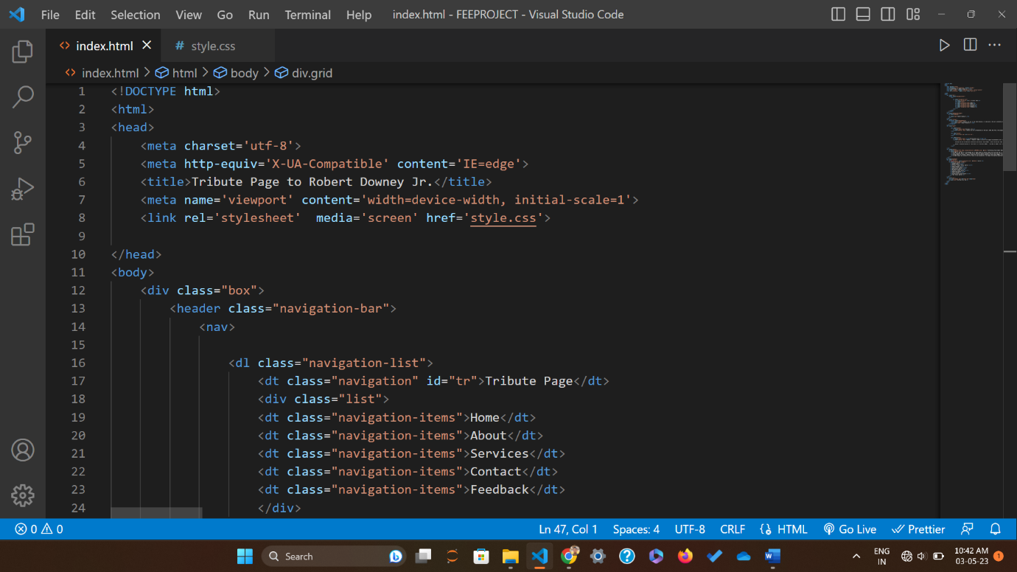

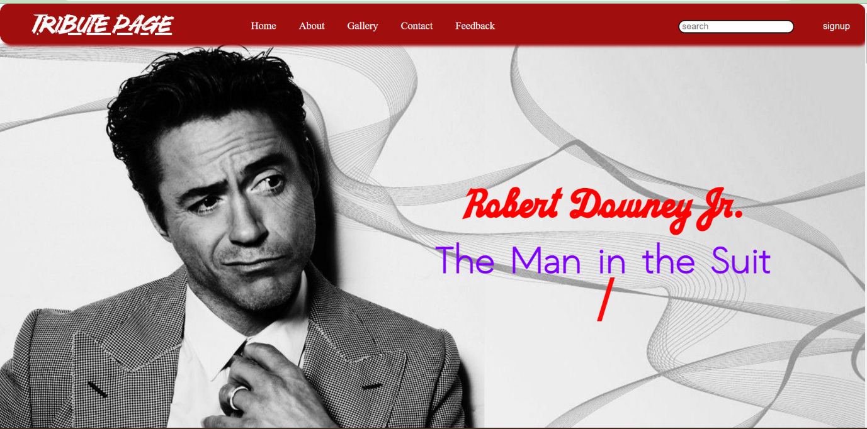

**7. Conclusion:**

The tribute web page project dedicated to Robert Downey Jr. serves as a comprehensive and engaging platform to honour his extraordinary life, illustrious career, and enduring impact. By providing a centralized source of information, multimedia content, and personal insights, the tribute page offers fans and enthusiasts a unique opportunity to delve into the remarkable journey of this iconic actor.

Through the incorporation of multimedia elements, such as images, videos, and quotes, the tribute page creates an immersive user experience that allows visitors to connect with Downey's performances and appreciate his immense talent. The inclusion of personal anecdotes and stories adds a human touch, inspiring and motivating fans with tales of resilience, personal growth, and redemption.

The project also highlights Downey's philanthropic endeavors, shedding light on his efforts to make a positive impact beyond the realm of acting. By promoting his advocacy work, the tribute page encourages others to get involved in charitable causes, fostering a sense of social responsibility among visitors.

Looking to the future, there are several potential avenues for expanding and enhancing the tribute web page project. One possibility is the integration of augmented reality (AR) or virtual reality (VR) elements, allowing users to immerse themselves even further into Downey's world. This could include virtual tours of movie sets, interactive experiences with digital representations of his characters, or behind-the-scenes glimpses into his creative process.

Additionally, the tribute page could continue to evolve by incorporating user-generated content, encouraging fans to share their own memories, artwork, or tributes. This would foster a sense of community and create a space where fans can connect and engage with one another, strengthening the bond and shared admiration for Downey.

Furthermore, as technology advances, the web page can leverage emerging trends such as artificial intelligence (AI) and machine learning to provide personalized recommendations, tailored content, or interactive chatbots that engage visitors in conversations related to Downey and his work.

In conclusion, the tribute web page project on Robert Downey Jr. serves as a testament to his exceptional talent, resilience, and impact on the entertainment industry. With its comprehensive content, engaging user experience, and potential for future expansion, the tribute page not only celebrates Downey's legacy but also offers a platform for fans to connect, share, and be inspired by his remarkable journey. It stands as a lasting tribute to a beloved actor and sets the stage for continued exploration and appreciation of his contributions in the years to come.

**8. References**

* 1. "Robert Downey Jr." - IMDb (Internet Movie Database) <https://www.imdb.com/name/nm0000375/>
     1. Year: Continuously updated
     2. Details: IMDb provides a comprehensive filmography, biography, awards, and trivia related to Robert Downey Jr. It is a reliable source for general information.
  2. "Robert Downey Jr." – Wikipedia <https://en.wikipedia.org/wiki/Robert_Downey_Jr>.
     1. Year: Continuously updated
     2. Details: Wikipedia offers an extensive overview of Robert Downey Jr.'s life, early career, personal struggles, and major filmography. It is a good starting point for gathering information, but always cross-reference with other sources for accuracy.
  3. “A pen on Robert Downey Jr.”-Google

<https://www.google.com/>

a. Year: march 2011

* 1. "Robert Downey Jr.: The Fall and Rise of the Comeback Kid" - Rolling Stone <https://www.rollingstone.com/tv-movies/tv-movie-news/to-hell-and-back-with-robert-downey-jr-170229/>
     1. Year: May 2008
     2. Details: This Rolling Stone article provides insights into Downey Jr.'s struggles with addiction, his career downturn, and his remarkable comeback in the late 2000s.
  2. “HTML”- W3 School

<https://www.w3schools.com/html/>